IoT-Based Forest Fire Detection and Prevention

Project ID: 26423 B.Tech. Project Report submitted for fulfilment of the requirements for the
Degree of Bachelor of Technology Under Biju Pattnaik University of Technology

Nitish Kumar Pradhan Aditya Maharana
Submitted By

ROLL NO. ECE201912240 ROLL NO. EEE201910386



2022 – 2023

Under the guidance of

Prof. Rajesh Kumar Dash

NIST INSTITUTE OF SCIENCE & TECHNOLOGY (Autonomous)

Institute Park, Palur Hills, Berhampur, Odisha – 761008, India

ABSTRACT

The Forest Fire is a serious issue as it caused the loss of a huge amount of land, property and lives of people and animals. Here the objective is to prevent this loss by detecting the fire at the right time and preventing the spreading of fire. Though the types of forests vary based on the area and geographical location so it is very difficult to propose a generalized solution for this type of problem. Instead, the system will be proposed for a particular type of forest which can be extended further for different forests. People are facing problems in the timely detection of fire due to which a lot of loss takes place, so detection is more important than prevention. So focus will be there to detect the process efficiently by using cutting-edge technology and upon detection right prevention techniques can be implemented based on the nature of the fire.

ACKNOWLEDGEMENT

It is our proud privilege to epitomize my deepest sense of gratitude and indebtedness to our advisor, Prof. Rajesh Kumar Dash for his valuable guidance, keen and sustained interest, intuitive ideas and persistent endeavour. His inspiring assistance, laconic reciprocation and affectionate care enabled us to complete our work smoothly and successfully.

We extend our sincere thanks to Prof. Rajesh Kumar Dash, B.Tech Project Coordinator and Prof. Bibhuti Bhusan Mishra, Department Project Coordinator for giving us the opportunity and motivating us to complete the Seminar within the stipulated period and providing a helping environment

We acknowledge with immense pleasure the sustained interest, encouraging attitude and constant inspiration rendered by Dr. Sukant K. Mohapatra (Chairman) and Dr. M. Suresh (HoD of Electronics & Communication Engineering) N.I.S.T. Their continued drive for better quality in everything that happens at N.I.S.T. and selfless inspiration has always helped us to move.

Nitish Kumar Pradhan Roll No. ECE201912240

Aditya Maharana Roll No. EEE201910386

TABLE OF CONTENTS
ABSTRACT i
ACKNOWLEDGEMENT ii
TABLE OF CONTENTS iii
LIST OF FIGURES iv
- INTRODUCTION 1
  - Objective 1
  - Existing Solution Vs Our Solution 2
- METHODOLOGY 3
  - Detection 3
  - Prevention 4
- COMPONENTS OF PROJECT DESIGN 6
  - Raspberry Pi 3 Model B+ 6
  - MQ 6 - Gas Leakage Sensor Module 7
  - MLX90614 Temperature Sensor 8
  - Flame Sensor Infrared Receiver Ignition Source Detection Module 9
  - NEO-6M GPS Module with EPROM 10
  - 3.7V 10000mAH Li-Po Rechargeable Battery 11
  - Solar India 3W 6V Polycrystalline Solar Panel 12
  - DC Motor 13
  - 5V Step-Up Power Module Lithium Battery Charging Protection Board
USB for DIY Charger 134N3P 13
- WORKING OF THE PROJECT 15
  - Workflow 16
  - Connection Diagram 17
  - Codes for Working of Project 18
- PREVENTION TECHNIQUE. 25
- PROJECT IMPLEMENTATION 34
  - Detection 34
  - Prevention 34
- FUTURE SCOPE 35
- CONCLUSION 36
REFERENCES 37

LIST OF FIGURES

Fig. 1.1 Fire Breakout in Forest 1
Fig. 1.2 Enabling IoT for forest fire detection 2
Fig. 2.1 Climate during fire breakout 3
Fig. 2.2 Raining Drone 4
Fig. 2.3 Aqua-Sphere raining 4
Fig. 2.4 Cloud Seeding 5
Fig. 2.5 Mechatronics Robot 5
Fig. 3.1 Raspberry Pi 3 Model B+ 6
Fig. 3.2 MQ 6 – Gas Leakage Sensor Module 7
Fig. 3.3 MLX90614 Temperature Sensor 8
Fig. 3.4 Flame Sensor 9
Fig. 3.5 Neo-6M GPS Module 10
Fig. 3.6 3.7V 1000mAH Li-Po Rechargeable Battery 11
Fig. 3.7 Solar Pannel 12
Fig. 3.8 DC Motor 13
Fig. 3.9 Charging / Discharging Module 14
Fig. 4.1 Block diagram of working of project 15
Fig. 4.2 Wokflow of the project 16
Fig. 4.3 Connection Diagram 17
Fig. 5.1 Raining Drone 25
Fig. 5.2 Cloud Seeding 27
Fig. 7.1 IoT enabled for analysis of the climatic condition of forest 35

INTRODUCTION

Objective

The incidence of forest fires in the country is on the increase and more area is burned each year. The major cause of this failure is the piecemeal approach to the problem. Here the objective is to prevent this loss by detecting the fire at the right time and preventing the spreading of fire. A simple and improved wireless protection system based on IoT needs to be designed against fire outbreaks and provide an early alarm to avoid serious damage due to these types of hazards. It should be a standalone alert system capable of communicating from any geographical location.

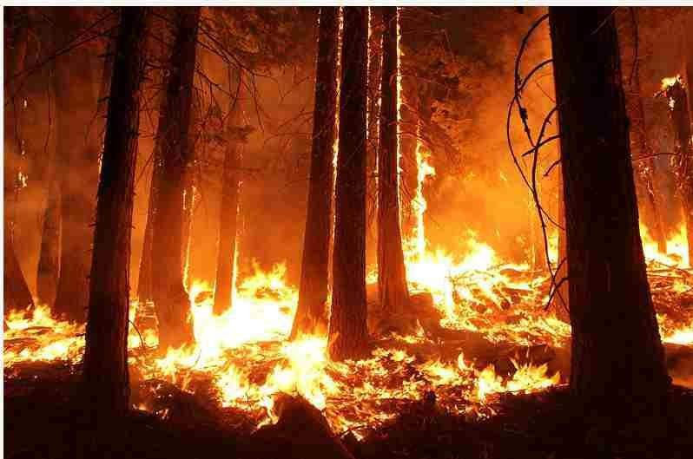

Fig. 1.1 Fire Breakout in Forest

Existing Solution Vs Our Solution

Nowadays, a satellite-based surveillance system is used to detect forest fires but this works when a fire is spread in a large area. So, these techniques are not efficient. According to a survey, approximately 80% of losses are accrued in the forest due to the late detection of fire. In future, we can decrease the loss rate significantly .A smart fire alert system is proposed with the help of microcontrollers and required sensors for the early detection of fire.

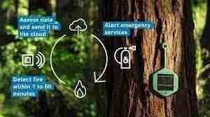

Fig. 1.2 Enabling IoT for forest fire detection

METHODOLOGY

Detection

Our methodology is to develop an improved solution for fire detection from existing solutions. The climatic conditions are different in different locations. So there can be many reasons for fire hazards in the forest. To design and implement an IoT based system which is self-sustaining and would predict and detect the forest fires. Sends the exact location to concerned officials which would help firefighting personnel to extinguish the fire in the location where it starts slowly.

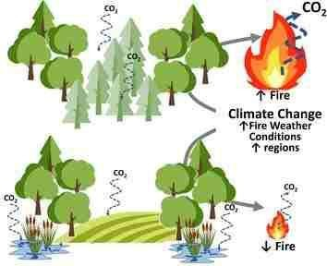

Fig. 2.1 Climate during fire breakout

Here we are focusing on parameters like,
- Temperature
- Humidity
- Smoke
- Climate
This comes with:
- Efficient communication technology
- Independent power source
- Reliable Infrastructure

Prevention

In prevention, we have several ideas,
- Aqua-Sphere Raining
- Raining Drones
- Cloud-Seeding
- High Torque Mechatronics Robots
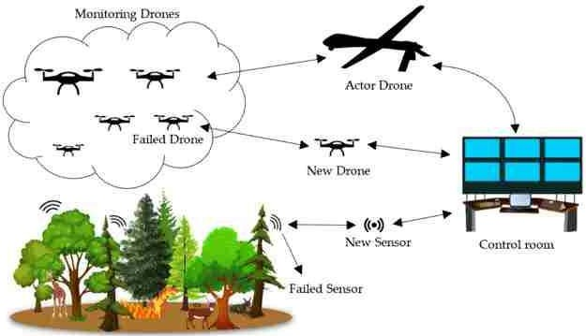


Fig. 2.2 Raining Drone

Fig. 2.3 Aqua-Sphere raining

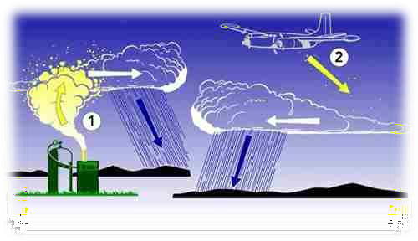
Fig. 2.4 Cloud Seeding

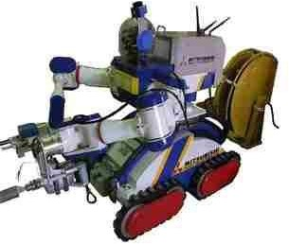
Fig. 2.5 Mechatronics Robot

These prevention methodologies will vary depending on the intensity and type of fire.

COMPONENTS OF PROJECT DESIGN

Raspberry Pi 3 Model B+

The final revision of our third-generation single-board computer with 1.4GHz 64-bit quad-core processor, dual-band wireless LAN, Bluetooth 4.2/BLE, faster Ethernet, and Power-over-Ethernet support (with separate PoE HAT)

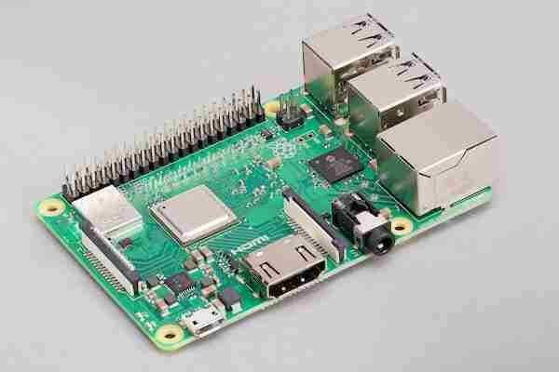

Fig. 3.1 Raspberry Pi 3 Model B+

Specifications
- Broadcom Bcm2837B0, Cortex-A53 (Armv8) 64-Bit Soc @ 1.4Ghz
- Bluetooth Low Energy V4.2 (Ble)
- Extended 40-Pin Gpio Header, 2.4Ghz And 5Ghz Ieee 802.11.B/G/N/Ac Wireless Lan, Bluetooth 4.2, Ble
- 4 X Usb 2.0 Ports
- Power Supply Requirements - 5V/2.5A Dc Via Micro Usb Or Gpio
- Graphics Card Interface:Integrated

MQ 6 - Gas Leakage Sensor Module

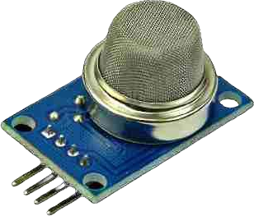
The MQ-6 module is used in gas leakage detecting equipment in family and industry, This module has high sensitivity to LPG, iso-butane, propane and LNG. It can also be used to detect the presence of alcohol, cooking fumes, and cigarette smoke.The module gives out the concentration of the gases as a analog voltage equivalent to the concentration of the gases. The module also has an onboard comparator for comparing against an adjustable preset value and giving out a digital high or low. It can be easily interfaced with your Arduino or Raspberry Pi.

Fig. 3.2 MQ 6 – Gas Leakage Sensor Module

Specifications
- The mq-6 gas sensor is highly sensitive to lpg, iso-butane, propane and less sensitive to alcohol, cooking fume and cigarette smoke
- Analog output voltage: 0~5v, the higher concentration, the higher voltage

MLX90614 Temperature Sensor

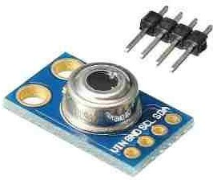
The MLX90614 ESF is an Infra-Red thermometer for non-contact temperature measurements. Both the IR-sensitive thermopile detector chip and the signal conditioning ASIC are integrated into the same TO-39 can. The Integrated MLX90614 GY-906 is a low noise amplifier, 17-bit ADC, and powerful DSP unit thus achieving high accuracy and resolution of the thermos.

Fig. 3.3 MLX90614 Temperature Sensor

Specifications
- Operating Voltage: 3.6V to 5V (available in 3V and 5V version)
- Supply Current: 1.5mA
- Object Temperature Range: -70° C to 382.2°C
- Ambient Temperature Range: -40° C to 125°C
- Accuracy: 0.02°C
- Field of View: 80°
- Distance between object and sensor: 2cm-5cm (approx.)

Flame Sensor Infrared Receiver Ignition Source Detection Module

This tiny Flame sensor infrared receiver module ignition source detection module is Arduino compatible can use to detect flame or wavelength of the light source within 760nm~1100nm also useful for Lighter flame detect at the distance 80cm.

Greater the flame, farther the test distance. It has the Detect angle of 60 and very sensitive to flame spectrum.

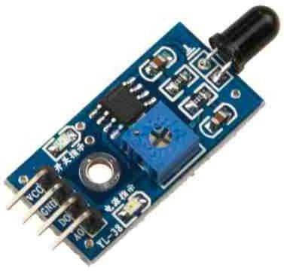
Fig. 3.4 Flame Sensor

Specification :
Operating Voltage (VDC) 3.3 ~ 5

Mounting Hole(mm) Length (mm)
Width (mm) Weight (gm) Shipment Weight
Shipment Dimensions
3
32
14
3
0.005 kg
4 × 2.5 × 2 cm

NEO-6M GPS Module with EPROM

This is a complete GPS module that is based on the NEO 6M GPS. This unit uses the latest technology to give the best possible positioning information and includes a larger built-in 25 x 25mm active GPS antenna with a UART TTL socket. A battery is also included so that you can obtain a GPS lock faster. This is an updated GPS module that can be used with ardupilot mega v2. This GPS module gives the best possible position information, allowing for better performance with your Ardupilot or other Multirotor control platform.

The GPS module has serial TTL output, it has four pins: TX, RX, VCC, and GND. You can download the u-center software for configuring the GPS and changing the settings and much more.
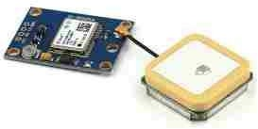
Fig. 3.5 Neo-6M GPS Module

Specification:
- Model

- Receiver Type

- Input Supply Voltage (VDC)
- Main Chip

- Sensitivity (dBm)

Ublox NEO-6M 50 Channels
GPS L1 frequency, C/A Code
SBAS: WAAS, EGNOS, MSAS 2.7 ~ 6
NEO-6
-160
156
Cold Start (without aiding): -147 dBm Tracking & Navigation: -161 dBm

- Navigation Update Rate 5Hz
- Position Accuracy (Meter) 2
- Operating Temperature Range (°C) -24 to 84

- Tracking Sensitivity (dBm)
- Avg Cold Start Time (s)
- Warm Start Time (s)
- Maximum Speed

- Dimensions (mm) LxWxH
-161 dBm
27
27
500 M/s
Antenna – 25 x 25 x 7
GPS Board – 22 x 30 x 4

3.7V 10000mAH Li-Po Rechargeable Battery

This is a 3.7V 10000mAh Lithium Polymer Rechargeable Battery also known as Li-po or Li-poly batteries. Having a wide range of applications, this 1260110 model Lipo batteries are thin, light, and powerful, and widely used in GPS, DVD, Tablet PC, Bluetooth speakers, IoT devices and other small portable devices.
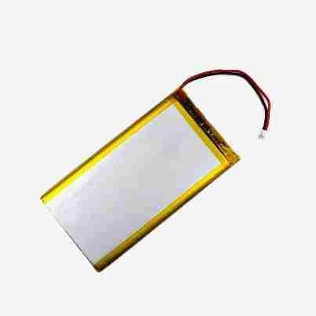
Fig. 3.6 3.7V 1000mAH Li-Po Rechargeable Battery

Specification:
- Size: 110 x 60 x 12 mm; No memory effect
- Environmentally friendly; 100% Brand New

- Battery Type: NV-1260110 Rechargeable Power Battery;
- Voltage: 3.7V; Capacity: 10000 mAh
- Rechargeable times: Up to 1800 times; Battery top: Flat top

Solar India 3W 6V Polycrystalline Solar Panel

The Solar India 3W 6V Polycrystalline Solar Panel is a great way to get started with solar power. This panel is perfect for small applications such as powering a small device or charging a small battery. Looking for a great solar panel that fits within your budget? Look no further than the solar panel from solar india. This panel is made of polycrystalline material and has 18 cells. It also has a short circuit current of 0.42 amps and a current at max power of 0.38 amps.
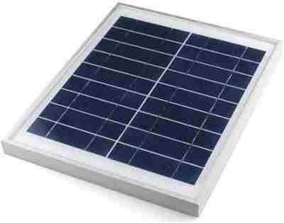
Fig. 3.7 Solar Pannel

Specification
- Android Mobile Charging
- 6v/4.5Ah SMF battery charging.
- Maximum Power :- 3 W
- Maximum Power Voltage :- 8.97 V.
- Panel Size with Frame: 20cmx20cmx1 cm

DC Motor

This DC motor is of non gear type motor having 35000 rpm.

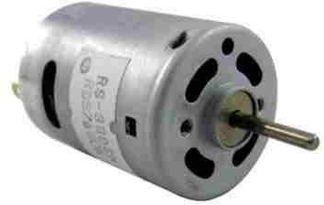

Fig. 3.8 DC Motor

Specification :
- Rated voltage:12V.
- No-Load Speed:35000±10% RPM/MIN; No-Load Current: 0.85A.
- Diameter 38.5mm.
- Length 57mm.
- Shaft 3.17mm.
- Weight: 255g(APPROX).

5V Step-Up Power Module Lithium Battery Charging Protection Board USB for DIY Charger 134N3P

5V Step-Up Power Module Lithium Battery Charging Protection Board USB For DIY Charger 134N3P Lithium Battery Charging Protection Board Boost Converter LED Display USB For DIY Charger 134N3PHigh-Quality USB iron with Cheap display port video card and Integrated Circuits.

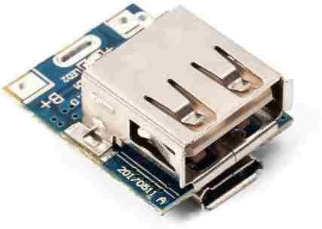

Fig. 3.9 Charging / Discharging Module

Specification:
- BAT Discharging Stop Voltage: 2.9V.
- Discharging Efficiency:85%(input 3.7V output 5V/1A).
- Charging and discharging indication.
- Internally installed charging and discharging power MOS.
- Preset 4.2V charging voltage, precision 1%.
- Max 8uA standby current.
- Integration charging management and discharging management.
- Intelligent temperature control and overtemperature protection.
- Integration output overvoltage protection, short circuit protection, overload protection.
- Integration overcharging and over-discharging protection.
- Support trickle mode and zero voltage charging.
- When charging: red light flashing.
- Fully charged: Red light glows for a long time.

WORKING OF THE PROJECT

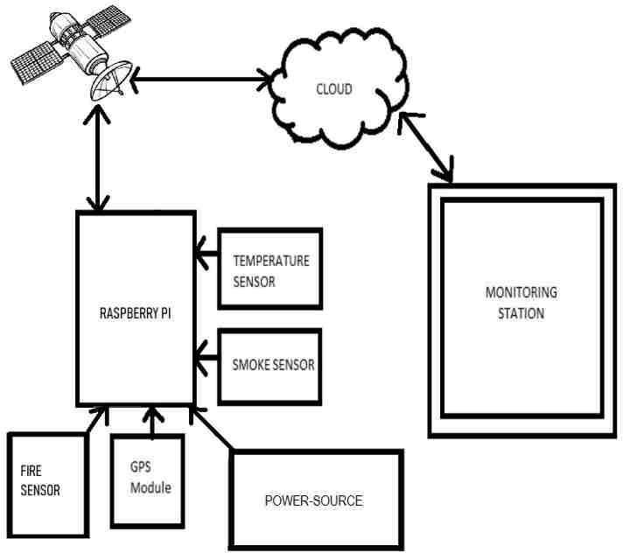

Fig. 4.1 Block diagram of working of project

Workflow

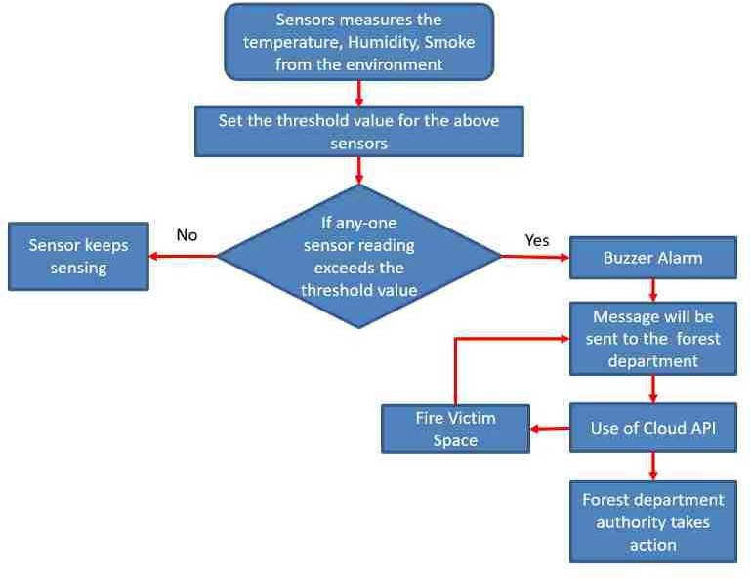

Fig. 4.2 Wokflow of the project

Connection Diagram

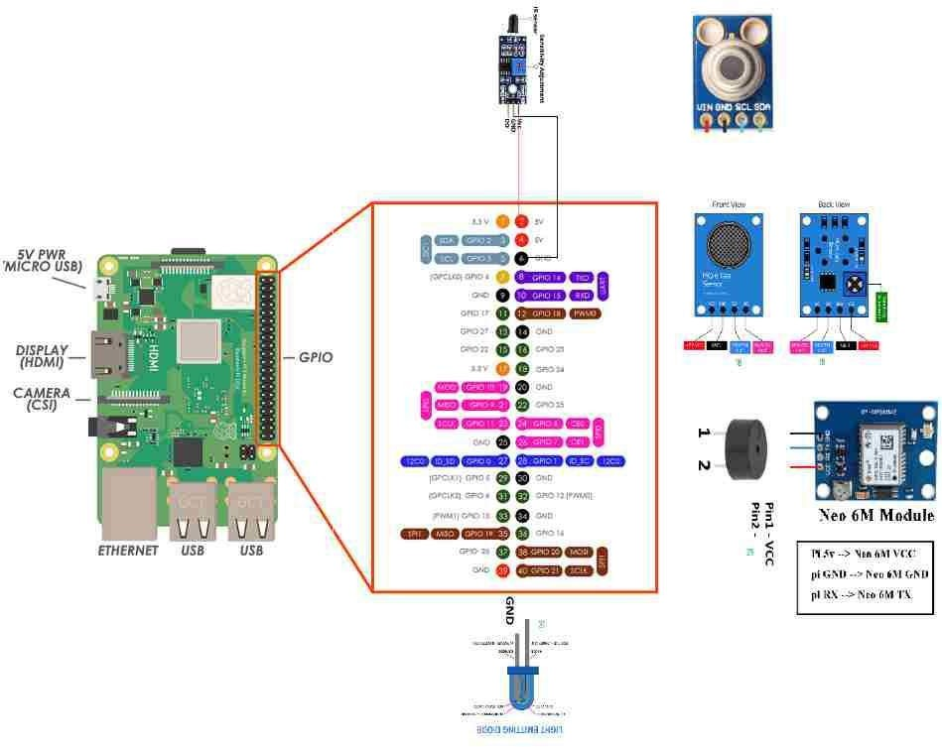

Fig. 4.3 Connection Diagram

Codes for Working of Project

import RPi.GPIO as GPIO # Import Library to access GPIO PIN from urllib.parse import urlparse
import paho.mqtt.client as paho from smbus2 import SMBus import board
import busio as io import adafruit_mlx90614 from time import sleep import serial
import time import string import pynmea2

from mlx90614 import MLX90614 import os,sys
import time

'GPIO.setmode(GPIO.BOARD)
GPIO.setwarnings(False)
# Consider complete raspberry-pi board' # To avoid same PIN use warning

# Define GPIO to LCD mapping LCD_RS = 7
LCD_E = 11
LCD_D4 = 12
LCD_D5 = 13
LCD_D6 = 15
LCD_D7 = 16
Buzzer_Pin = 29
MQ6_Pin = 18
Fire_Pin = 21
LED_Pin = 31

# Define PIN for Buzzer
# Define PIN for MQ2 Sensor

GPIO.setup(Buzzer_Pin,GPIO.OUT) # Set pin function as output

GPIO.setup(MQ6_Pin,GPIO.IN,pull_up_down=GPIO.PUD_UP) function as input GPIO.setup(Fire_Pin,GPIO.IN,pull_up_down=GPIO.PUD_UP) GPIO.setup(LCD_E, GPIO.OUT) # E
GPIO.setup(LCD_RS, GPIO.OUT) # RS GPIO.setup(LCD_D4, GPIO.OUT) # DB4 GPIO.setup(LCD_D5, GPIO.OUT) # DB5 GPIO.setup(LCD_D6, GPIO.OUT) # DB6 GPIO.setup(LCD_D7, GPIO.OUT) # DB7 GPIO.setup(LED_Pin, GPIO.OUT)

i2c = io.I2C(board.SCL, board.SDA, frequency=100000) mlx = adafruit_mlx90614.MLX90614(i2c)

def on_connect(self, mosq, obj, rc): self.subscribe("Fan", 0)
# Set pin

def on_publish(mosq, obj, mid): print("mid: " + str(mid))
mqttc = paho.Client() # object declaration # Assign event callbacks
mqttc.on_connect = on_connect mqttc.on_publish = on_publish

url_str = os.environ.get('CLOUDMQTT_URL', 'tcp://broker.emqx.io:1883') url = urlparse(url_str)
mqttc.connect(url.hostname, url.port)

# Timing constants E_PULSE = 0.0005
E_DELAY = 0.0005
delay = 1

# Define some device constants
LCD_WIDTH = 16 # Maximum characters per line LCD_CHR = True
LCD_CMD = False
LCD_LINE_1 = 0x80 # LCD RAM address for the 1st line LCD_LINE_2 = 0xC0 # LCD RAM address for the 2nd line LCD_LINE_3 = 0x90# LCD RAM address for the 3nd line

'''
Function Name :lcd_init()
Function Description : this function is used to initialized lcd by sending the different commands
'''
def lcd_init():
# Initialise display lcd_byte(0x33,LCD_CMD) # 110011 Initialise lcd_byte(0x32,LCD_CMD) # 110010 Initialise
lcd_byte(0x06,LCD_CMD) # 000110 Cursor move direction lcd_byte(0x0C,LCD_CMD) # 001100 Display On,Cursor Off, Blink Off lcd_byte(0x28,LCD_CMD) # 101000 Data length, number of lines, font size lcd_byte(0x01,LCD_CMD) # 000001 Clear display
time.sleep(E_DELAY) '''
Function Name :lcd_byte(bits ,mode)
Fuction Name :the main purpose of this function to convert the byte data into bit and send to lcd port
'''
def lcd_byte(bits, mode): # Send byte to data pins # bits = data
# mode = True for character # False for command

GPIO.output(LCD_RS, mode) # RS

# High bits GPIO.output(LCD_D4, False) GPIO.output(LCD_D5, False) GPIO.output(LCD_D6, False) GPIO.output(LCD_D7, False) if bits&0x10==0x10: GPIO.output(LCD_D4, True) if bits&0x20==0x20: GPIO.output(LCD_D5, True) if bits&0x40==0x40: GPIO.output(LCD_D6, True) if bits&0x80==0x80: GPIO.output(LCD_D7, True)

# Toggle 'Enable' pin lcd_toggle_enable()

# Low bits GPIO.output(LCD_D4, False) GPIO.output(LCD_D5, False) GPIO.output(LCD_D6, False) GPIO.output(LCD_D7, False) if bits&0x01==0x01: GPIO.output(LCD_D4, True) if bits&0x02==0x02: GPIO.output(LCD_D5, True) if bits&0x04==0x04: GPIO.output(LCD_D6, True) if bits&0x08==0x08: GPIO.output(LCD_D7, True)

# Toggle 'Enable' pin lcd_toggle_enable() '''
Function Name : lcd_toggle_enable()
Function Description:basically this is used to toggle Enable pin '''
def lcd_toggle_enable():
# Toggle enable time.sleep(E_DELAY) GPIO.output(LCD_E, True) time.sleep(E_PULSE) GPIO.output(LCD_E, False) time.sleep(E_DELAY)
'''
Function Name :lcd_string(message,line) Function Description :print the data on lcd '''
def lcd_string(message,line): # Send string to display

message = message.ljust(LCD_WIDTH," ")

lcd_byte(line, LCD_CMD)

for i in range(LCD_WIDTH): lcd_byte(ord(message[i]),LCD_CHR)

lcd_init()
lcd_string("welcome ",LCD_LINE_1) time.sleep(0.5)
lcd_string("Fire Detection ",LCD_LINE_1) lcd_string("System ",LCD_LINE_2)
time.sleep(0.5)
lcd_byte(0x01,LCD_CMD) # 000001 Clear display # Define delay between readings
delay = 5

bus = SMBus(1)
sensor = MLX90614(bus, address=0x5A) while (1):
ambientTemp = "{:.2f}".format(mlx.ambient_temperature) targetTemp = "{:.2f}".format(mlx.object_temperature)

sleep(1)

print("Ambient Temperature:", ambientTemp, "°C") print("Target Temperature:", targetTemp,"°C")

rc = mqttc.loop()
#Check switch pressed or not
if GPIO.input(MQ6_Pin ) == GPIO.LOW or GPIO.input(Fire_Pin) == GPIO.LOW
:
lcd_string("Fire Detected",LCD_LINE_1) lcd_string("Alaram ON",LCD_LINE_2) print ("Fire Detected and Alaram ON") port="/dev/ttyAMA0"
ser=serial.Serial(port, baudrate=9600, timeout=0.5) dataout = pynmea2.NMEAStreamReader() newdata=ser.readline()

if "$GPRMC" in str(newdata): newmsg=pynmea2.parse(newdata.decode('utf-8')) lat=newmsg.latitude
lng=newmsg.longitude
gps = "Latitude=" + str(lat) + "and Longitude=" + str(lng)
print(gps) print(newdata)
map_link = 'http://maps.google.com/?q=' + str(lat) + ',' + str(lng)#create link to plot location on Google map

mqttc.publish("gas","1") GPIO.output(Buzzer_Pin,GPIO.HIGH) #Buzzer ON GPIO.output(LED_Pin,GPIO.LOW) #LED ON
else :
lcd_string("Fire Not Detected",LCD_LINE_1) lcd_string("Alaram OFF",LCD_LINE_2)
print ("Fire not Detected and Alaram OFF") GPIO.output(Buzzer_Pin,GPIO.LOW) #Buzzer OFF GPIO.output(LED_Pin,GPIO.HIGH) #LED OF

PREVENTION TECHNIQUE

Aqua-Sphere raining :
During a wildfire, dousing the flames with water is often the best method of fire control. This can be done with a fire hose, a water pump, or even a bucket of water. Dousing the fire with water will help to extinguish the flames and prevent the spread of the fire.

By using water mist, the amount of water in the fire tank is able to fight the fire over a much bigger area.

Raining Drones:

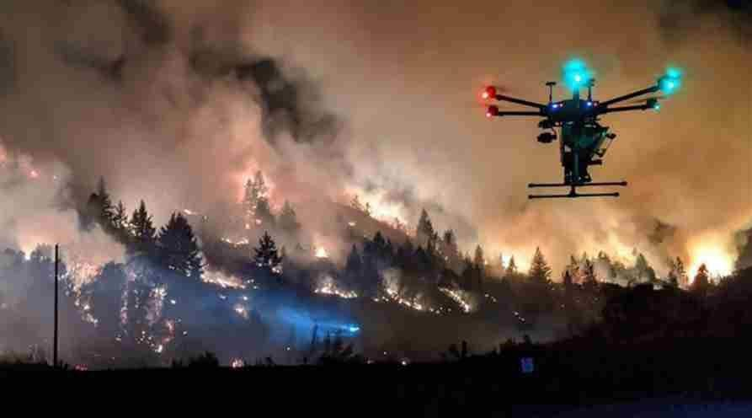
Fig. 5.1 Raining Drone

As wildfires in the United States have gotten larger and deadlier in recent years, one start- up is employing drones and fire-starting dragon eggs to help avoid catastrophic blazes and save the lives of firefighters. Preventing wildfires with dragon eggs can be laborious and risky at times for firefighters of today.
Drone Amplified, a Nebraska-based firm, is employing unmanned aerial technology to improve prescribed burns, one of the oldest and most efficient techniques of wildfire prevention. The controlled application of fire by a team of professionals to eliminate dangerous fuel in places prone to wildfires is referred to as drones carrying dragon eggs. According to the US Forest Service, “more managed burns imply fewer severe wildfires.” According to Carrick Detweiler, founder, and CEO, drone-driven dragon eggs work by “doing a very low-intensity burn that usually burns up the dead leaves and sticks that would cause major wildfires later in the summer.”

In 2017, two engineering professors from the University of Nebraska-Lincoln founded the start-up. The National Science Foundation and the Nebraska Department of Economic Development gave it a $1 million grant for research and development in 2020.

“When it’s safe to do so, we can decrease these massive flames by employing more fire,”
Detweiler continued.

According to Detweiler, firefighters frequently must travel or ride an all-terrain vehicle into deep forest or hilly terrain while carrying a drip torch to ignite tiny fires in specific, inaccessible spots. “Then there are helicopters with a complete crew on board, flying incredibly low and slow above the fire,” he said of additional controlled burn tactics.

The drones contain “dragon eggs,” or fireballs that erupt when they hit the ground. “They have potassium permanganate,” Detweiler explained of the dragon eggs, explaining that when this is mixed with glycol, a chemical reaction occurs, resulting in a fire. A single 50-pound drone may accommodate 400 of these fireballs.

According to Detweiler, drones allow firefighters to operate at a safe distance from the flames and in regions that are difficult to access owing to topography or visibility. Furthermore, firefighting technology may be employed “when it’s dark, smoky, and other planes can’t be out there.”
The drones, which are controlled by an app, can also drop the fire-starting balls in precise areas. Precision is essential while performing controlled burns since it helps to avoid fire escapes.

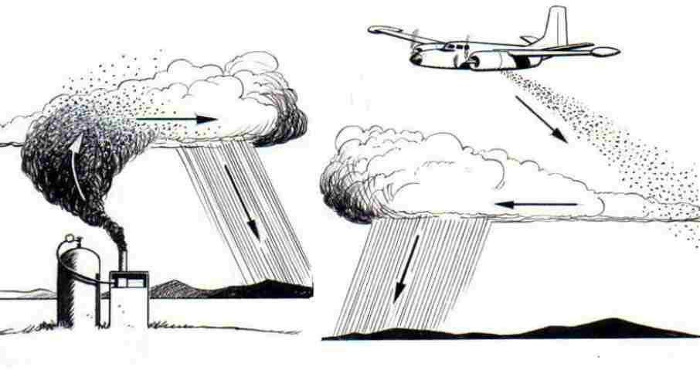
Cloud-Seeding :
Fig. 5.2 Cloud Seeding

Huge forest fires are raging in Siberia, Russia. Russian authorities are working to extinguish an area of about 46 thousand hectares. Russian firefighters are now allegedly being aided with the help of aircraft spraying chemicals to manipulate clouds to produce rain.

It is a well known fact that large forest fires are very difficult to stop unless the fire fighting efforts are helped by a change in weather from dry to wet. To stop the recent fires, Russia has used a previously proven method called cloud seeding, which is to prepare clouds with chemicals.
"This method aims to control how much rain an area receives and where the rain falls. This is not a method entirely without risks, says Swedish Television´s meteorologist Josefine Bergstedt.

"One of the most effective chemicals is silver iodide, and it is not completely harmless to humans and animals", she says.

According to an article in The National Post, on July 10, the Russian forestry agency said active work was underway to battle 158 forest fires covering 46,261 hectares as of Friday. Just a few days earlier, the effected area was more than three times larger.

States of emergency have been declared in the regions of Krasnoyarsk and Yakutia, and in parts of several other Russian regions.

Scientists say they expect record-breaking temperatures in Siberia – which reached as high as 38 Celsius (more than 100 degrees Fahrenheit) last month, according to reports – will continue to spawn wildfires and cause more greenhouse gases to be released into the air.

Copernicus, the EU’s earth observation program, said that temperatures in Arctic Siberia had soared to a record average for June, more than 5 degrees Celsius (9°F) above normal.

Mechatronics Robot:
A fire outbreak is a hazardous act that leads to numerous consequences. Detecting a fire at an early stage and extinguishing it can aid in prevention of various accidents. Till now we rely on human resource. This often leads to risking the life of that person. Therefore, fire security becomes an important aspect to save human lives. In this paper a fire extinguishing robot has been proposed and designed which detects the fire location and extinguish fire by using sprinklers on triggering the pump. This robot uses three flame sensors for accurate fire detection. This proposed model of Fire Extinguishing Robot using Arduino used to detect presence of fire and extinguishing it automatically without
any human interference. It contains gear motors and motor driver to control the movement of robot when it detects any presence of fire and will automatically start the water pump to extinguish that fire breakout. This model robot has a water ejector which is capable of ejecting water at the fire breakout place. The water ejector pipe can be move towards the required direction using servo motor. The whole operation is controlled by an Arduino UNO micro-controller.

In today’s era fire fighting is an dangerous issue. Many authors are working on different techniques for fire fighting. Author Ratnesh Malik et al. has developed an approach towards fire fighting robot. The robot is designed and constructed which is able to extinguish fire. The robot is fully autonomous.

It implements the concept likes environmental sensing and awareness, proportional motor control. The robot processes information from its sensors and hardware elements. Ultraviolet, Infrared and visible light are used to detect the components of environment. The robot is capable of fighting tunnel fire, industry fire and military applications are designed and built. Ultraviolet sensors are used to detect fire. Once fire is detected, robot sounds an alarm. Then the robot activates an electronic valve which release sprinkles of water on the flame. Detailed concept of robot is explained which automatically detects fire and extinguishes it in short time by the use of sensors, microcontroller etc. This robot is used in places where human lives are at high risk .

Author Kristi Kokasih et al. has developed intelligent fire fighting tank robot. Tank robot is made from acrylic, plastic, aluminum and iron. Robot components are two servo motors, two DC motors, ultrasonic sensor, compass sensors, flame detector, thermal array sensor, white detector (IR and photo transistor) , sound activation circuit and micro switch sensor. The objective is to search certain area, find and extinguish the flame for different flame positions, room configuration with disturbance. Robot is activated through DTMF transmitter and receiver .
Control Of An Autonomous Industrial Fire Fighting Mobile Robot is developed by H.P. Singh et al. The paper describes the construction and design of mobile fire fighting robot. The system contains two optically isolated D.C. motors. Robot performs analog to digital conversion of the data provided by infrared sensors. Five infrared sensor are used. Two sensors control the motion of the robots and three are for flame detection. The extinguisher comprises of D.C water pump and a water container. The basic theme of the paper is to sense the flames of fire and extinguish it. For this infrared sensor is used as input sensor which senses the infrared rays coming out of the fire. The microcontroller controls the extinguishing system.

Wireless fire fighting robot is developed by Swati Deshmukh et al. It comprises of machine which has ability to detect fire and extinguish it. The fire fighting robot can move in both forward and reverse direction and can turned in left and right directions. Thus fire fighter can operate the robot over a long distance and there is no need for human near the area on fire. Light dependent resistors are used for detection of fire. These resistors are highly sensitive devices and are capable of detecting very small fire. The robot provides security at home, buildings, factory and laboratory. It is an intelligent multisensory based security system which contains fire fighting system in daily life.

Cell phone controlled robot with fire detection sensors developed by Lakshay Arora consist of mobile phone which controls a robot by making a call to the mobile phone which is attached to the robot. During the call activation period, if any button is pressed on the phone, the tone corresponding to the button pressed is heard at the other end of the call that is placed on the robot. The robot perceives Dual-Tone Multiple-Frequency (DTMF) tone with the help of phone mounted on the robot. The received code is processed by the microcontroller and then the robot performs actions accordingly. In the proposed system DTMF technology is used to position the shaft of motor at a required point with different sensors, each performing its own task. Rugged, Simple and cost effective system is proposed here.
Android Phone controlled Robot Using Bluetooth is developed by Arpit Sharma et al. Various techniques of Human Machine interaction using gestures are presented. Gestures are captured by using the accelerometer. The paper analyses the motion technology to capture gestures using an android smart phone which has inbuilt accelerometer and Bluetooth module to control kinetics of the robot. The microcontroller controls the signals of the Bluetooth module. Features like user friendly interface, lightweight and portability OS based smart phone has overtaken the sophistication of technologies like programmable glove, static cameras etc making them obsolete.

Author SaravananP has designed and developed an Integrated Semi-Autonomous Fire Fighting Mobile robot. The System controls four D.C. motors powered by Atmega2560 and controlled autonomously by navigation system. Navigation system comprises of integrated ultrasonic sensors and infrared sensors. The robot is fitted with wireless camera which captures the video and transmits it to the base station. The fire detection comprises of LDR and temperature sensor. If there is a fire the sensor detects it and the robot will be moved to the source and extinguishes it. The extinguishing system consists of a BLDC motor with water container. The SABOT can be operated manually for extreme conditions. It comprises of a GUI support through which robot can be controlled from the base station.

Intelligent Fire Extinguisher System is developed by Poonam Sonsale et al. The paper proposes of an adaptive fusion algorithm for fire detection. It uses a smoke sensor, flame sensor, temperature sensor for fire detection. It contains intelligent multisensory based security system that contains a fire fighting system in daily life. The security system can detect abnormal and dangerous situation and notify. Intelligent buildings are expected to be safer convenient and efficient living environments for society. The purpose of Intelligent Fire Extinguisher System is to extinguish flame in a certain amount of time. The system detects the fire location and extinguish fire by using sprinklers. As being Intelligent System, it cuts off the electricity of area where fire has been caught and starts the sprinklers only of that area.
Remote Controlled Fire Fighting Robot developed by Phyo Wai Aung describes the functions of remote control fire fighting robot. It contains two main parts that is transmitter and receiver in which two sets of RF modules are used. One RF module is used to transmit the data to the motor driver and another RF module is used to know the condition on fire. Microcontroller PIC16F887 is used operate the whole system of the fire fighting robot. The motors are driven by the L298 and ULN2003 drivers in this system. The operator controls the robot by using wireless camera mounted on the robot. If the temperature of fire sight is above 40 degree Celsius, the alarm will be ringing so that operator can control the fire fighting robot and avoid the damage of heat.

To design and build a small Fire Fighting robot, where a robot will be put in a house model where a light candle is available and the robot should be able to detect, and extinguish the candle in the shortest time while navigating through the house and avoiding any obstacles in the robot's path. Researches were done in the beginning of the project to get more information about robotics in general and to think about the design, hardware components, and the software technique which will control the robot. This robot contains Light Sensor, 2 DC motors, and Buzzer is used in the robot's body. Two DC series motors are used to control the rear wheels and the single front wheel is free. The software part of the project is the program code written in the micro-controller to control the Fire Fighting Wireless Controlled robot Using 8051.

Detecting the fire and extinguishing it is a dangerous job and that puts lives of fire fighters at risk. There are number of fire accidents in which fire fighter had to lose their lives in the line of duty each year throughout the world. Increase in the number fire accidents are due to expanding human population and growing industrialization. The physical limitations of humans to deal with these kinds of destructive fires make fire extinguishing a complicated task. The use of fire fighting robots can reduce the errors and the limitations that are faced by human fire fighters. This paper contains various methods for implementation of fire fighting robots. Here we compare various design and construction of building a fire fighting robot.
When we the field of firefighting has long been a dangerous one, and there have been numerous and devastating losses because of a lack in technological advancement. Additionally, the current methods applied in firefighting are inadequate and inefficient relying heavily on humans who are prone to error, no matter how extensively they have been trained. A recent trend that has become popular is to use robots instead of humans to handle fire hazards. This is mainly because they can be used in situations that are too dangerous for any individual to involve themselves in. In our project, we develop a robot that is able to locate and extinguish fire in a given environment. The robot navigates the area and avoids any obstacles it faces in its excursion. Hear about robots, we think of science fiction novels and sci-fi movies. It is due to the fact that we do not know how to create robots of high intelligence.

Over last few decades, some the systems have been developed, namely “Fire Extinguishing Robot” and “A smart fire extinguisher using fire fighting robot” in which black line path is assigned so following those path robots were used to extinguish the fire. Also, robots are designed as tank robot with the flame, ultrasonic, thermal array, and compass sensor. Its simulation area is designed in miniature, it's miniature equipped with furniture, sound damper, and uneven floor. But the use of various sensors makes the design complicated, there will be a possibility of messing up the output. This system is fully automated fire fighting robot which deals with the fire problems in the household, laboratories, small scale industries. We can use this robot to perform those tasks that may be harmful and dangerous to humans. From the literature review it is clear that to solve problems created while operating the robot manually or through coding, intelligent design is made which constitutes addresses of various locations. This makes human life easier and reduces the efforts taken by them. This system composed of an IR sensor to detect the flame from the surrounding environment based on the data from sensors, because its speed and accuracy are better than gas and smoke sensor.

PROJECT IMPLEMENTATION

Detection

Here in this model the detection part we have implemented the sensor like temperature sensor, GPS module, IR heat sensor, MQ 6 gas sensor that will continuously accumulate all type of environment parameter data into the sensor and convert that into digital data and send it to the Raspberry. Then the Raspberry pie will match those values with attached threshold value that is given by the safety parameters if that value exceeds those threshold values then it will act and respond that there is a fire burst in the forest and will send the GPS location to the forest department.

Prevention

We have tried to implement two methods one of them is the application of motor instead of mechatronics robot that will throw the sand into the fire so that the fire won’t get enough oxygen to get on burning and the second method is the water droplets that will stop the spreading of the fire.

FUTURE SCOPE

No project is ever perfect and the same goes for our project as well. Hence, we figured out several areas of improvement that can be achieved with better technology and a bit of more funding. Some promising future scopes of for the project are:
- Try to build a product.
- Miniaturization of the whole system.
- Running the system with least power.

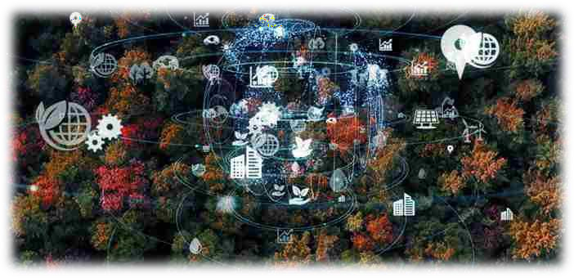

Fig. 7.1 IoT enabled for analysis of the climatic condition of forest

CONCLUSION

It is an effective method for fire detection in forests that provides more accurate results. The proposed system is easy to set up. The efficiency of automated systems is more than that of manual systems. This further eliminates human intervention.

We are also getting benefits from aspect of engineering such as Communication Technology, Communication between sensors controlling either wire or wireless, Problem-solving approach for a real-time problem by using Engineering, Cloud Technology.

REFERENCES
- Ransing, Rasika S., and Manita Rajput. "Smart home for elderly care, based on Wireless Sensor Network." 2019 International Conference on Nascent Technologies in the Engineering Field (ICNTE). IEEE, 2019.
- Sharma A, Ansari M, Siddiqui M, Baig M (2019) IOT enabled forest fire detection and online monitoring system. Int J Curr Trends Eng Res (IJCTER) 3(5):50–54.
- Cantuna JG, Bastidas D, Solorzano S, Clairand J (2020) Design and implementation of a wireless sensor network to detect forest fires. In: 2020 Fourth international conference on eDemocracy & eGovernment (ICEDEG)
- Imteaj, Rahman, Husain, M. K., Alam, M. S., & Rahat, S. A. (2017, February), “An IoT based fire alarming and authentication system for workhouse using Raspberry Pi 3,” in Electrical, Computer and Communication Engineering (ECCE), International Conference on (pp. 899-904). IEEE.
- Guilherme Borba Neumann, Victor Pinheiro de Almeida and Markus Endler,
“Smart Forests: fire detection service.”
- Sathishkumar R, Vinothkumar, M, Devaraj Varatharaj, S., & Gowthaman, S. M. (2016), “Design and Development of Automatic Fire Detection Using SMS and Voice Alert System,” International Journal of Scientific & Engineering Research, 7(5), 114-117.

